Daily Checklist

1. If you saturated your soil mix with water as you blended it into your frame, then water daily or weekly according to your garden plant’s needs.* Check every day to see which, if any of the plants seems even just a little droopy. If you have used the blended soil mix, it is unlikely that you would ever over water, as this mix allows perfect drainage. See page 150-154 of The “All New Square Foot Gardening” book.

2. Examine plants for pests and/or diseases (don’t forget undersides of leaves.)
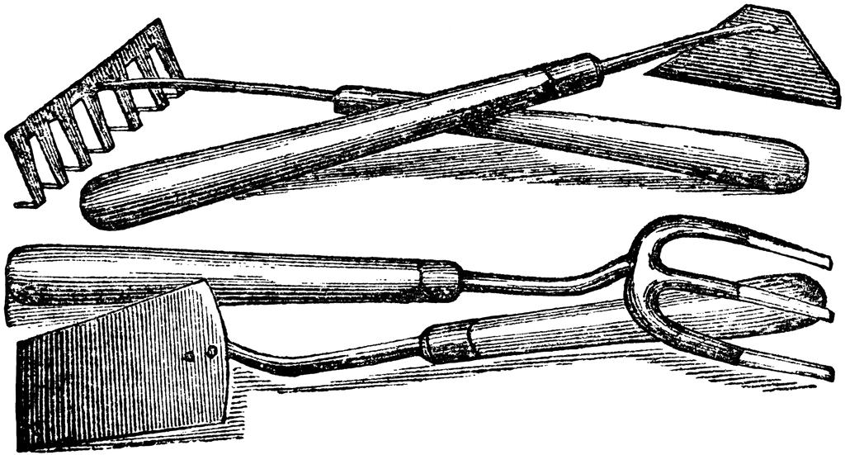
3. Destroy pests in a bucket of soapy water.
4. Pinch off any leaves that have signs of disease or pests.
5. Scrape any egg clusters off the backs of leaves.
6. Keep suckers picked off tomatoes.
7. Pull out any weeds.
8. Break off any branches or leaves of plants touching the dirt.
9. Keep suckers, weeds, healthy leaves, etc. Let them dry in the sun and then incorporate them back into your soil.
10. Watch for cutworms – if they are cutting down your plants, they will usually be in the soil at the base of the cut plant during the day.
11. Watch branches of cucumbers. Keep pinched back to 15 inches.

*Water: 1” rain per week = 2 ½ quarts/week per square foot
Tip: Plant impatiens near tomatoes, peppers, beans, etc. to gauge when they need water. If impatiens wilts, water the fruit and seed vegetables. Also take into account when it rains and adjust your manual watering if necessary.

